Bar color: **#00FFC2**

Font: Rajdhani <https://fonts.google.com/specimen/Rajdhani>

Intended appearance with text:

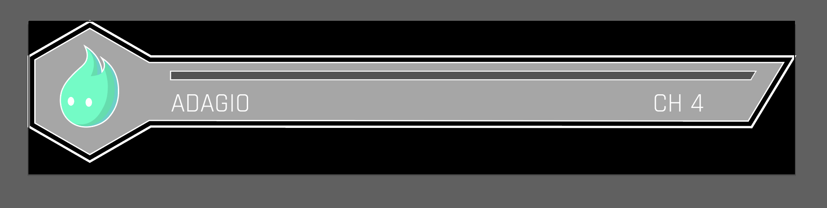

Parrying Meter: Empty

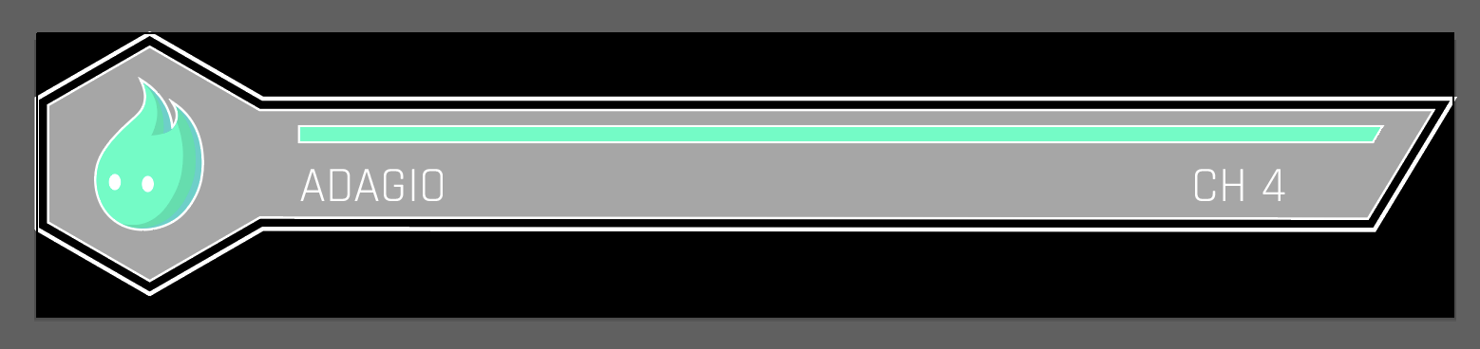

Parrying Meter: Full